**Hyperlinks Integrity Checker for Web Document Report**



# Name1: Alaa Hossam Abdelmawla

ID1: 6750

Name2: Manar Amgad Helal

ID2: 7113

At first we will give a little bit overview about our implementation of to the hyperlinks integrity checker ; first of all we import jsoup jar in our program in java to be able to use html methods or variables in the program .our code consists of one package and 4 main class : ExtractLinks – ValidationLinks – Threads – Linksanddepth and one GUI called input has three labels and three text fields ; which takes the link as an input from user to check it , number of depth the user wants and the number of threads which the user wants to make the performance better; and button called ok to run the program.

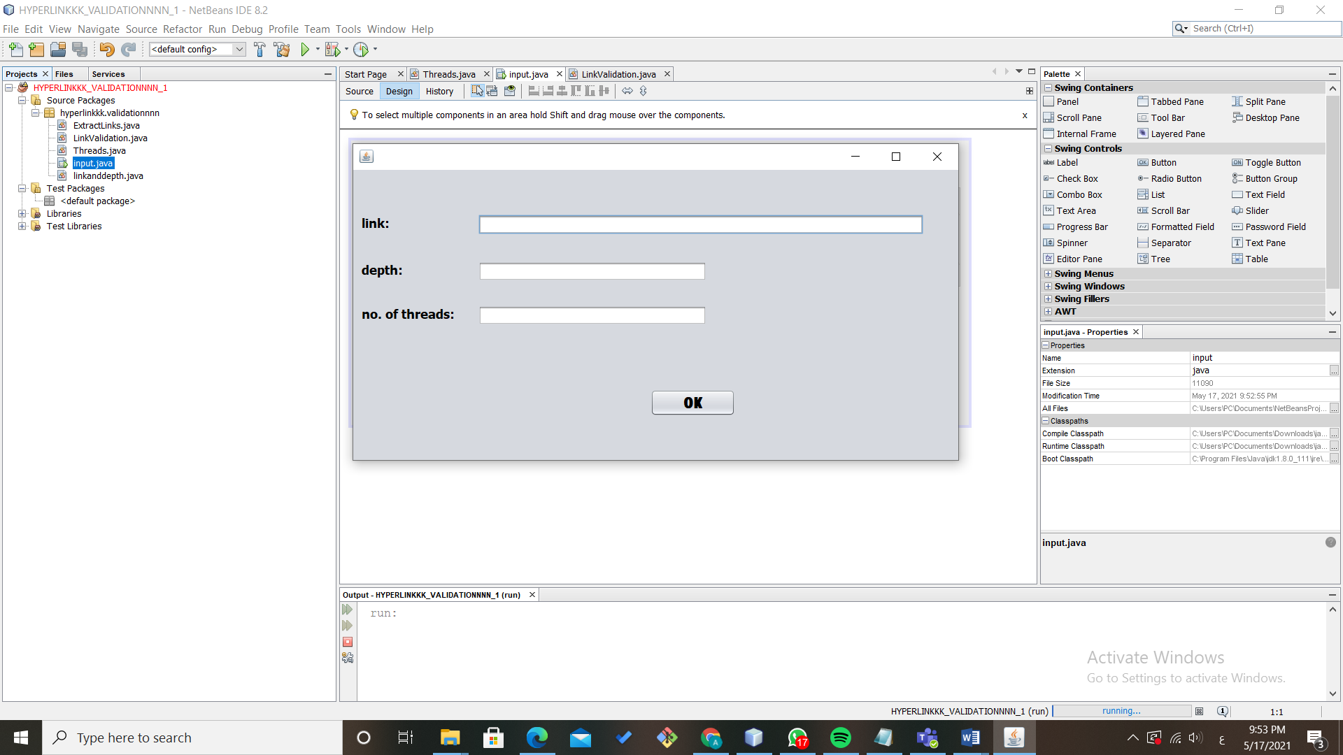

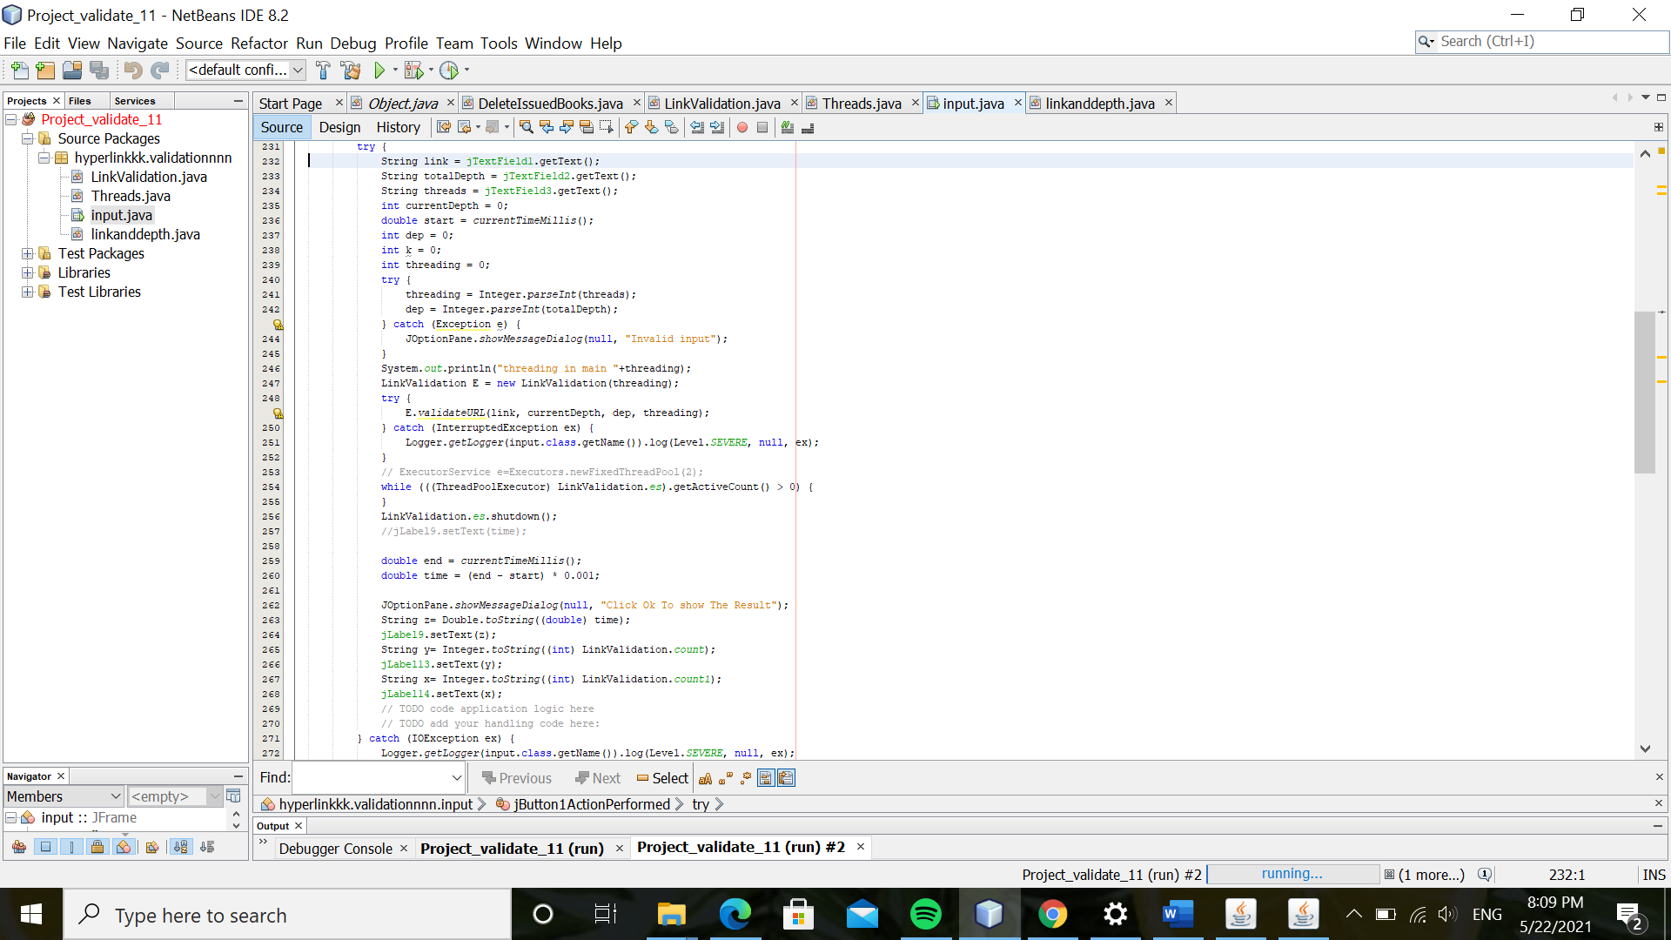

Algorithm:

ValidationLinks: this class has two methods one called validateOneURL and this checks the type of exceptions or errors in each link for example if the link has ERROR 404 it will display a message “PAGE NOT FOUND” and if it is IOEXCEPTION it will display a message “SERVER NOT FOUND” and all this done by try catch statement. And another method called validateURL : it takes four parameters : the link , the depth which we initialize it from 0 and inrcement it to the total depth the third parameter which we take from the user and the number of threads which we also take it as an input.

we made a recursive statement at the beginning of this method to check if the current depth == the total depth.

We made an empty constructor LinkValidation and another constructor LinkValidation to call the variable threading which we take as input inside the executerService which we use to make the threading in our program.

We made 2 counters one to count the valid links and the second count the invalid links and we made them static to be able to call them in our main in the GUI.

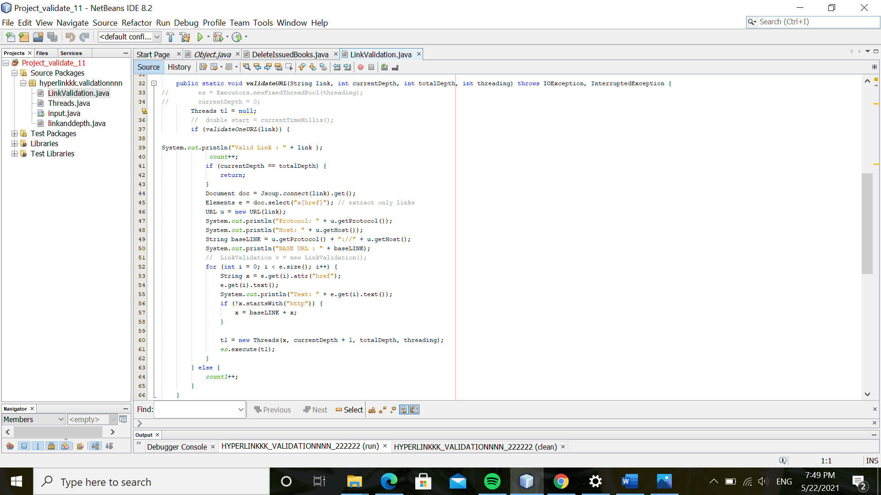

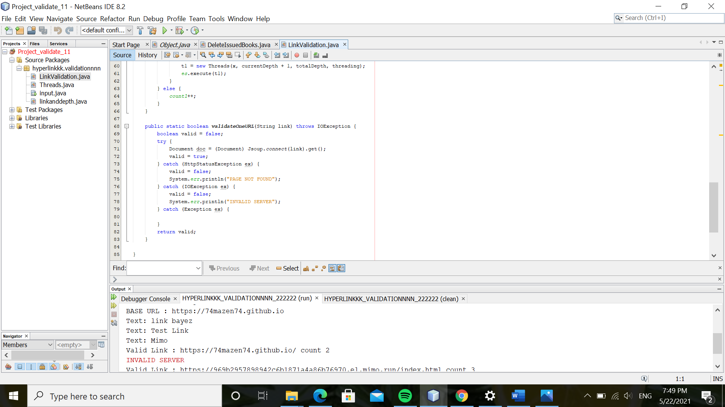

Threads: in this class we made three private variables : link , depth , maxdepth and no of threads which we take from the user and private constructor takes the same 4 variables as parameters , this class extends thread from java and make public void main run for this thread extention and it has try catch statement to check the exceptions

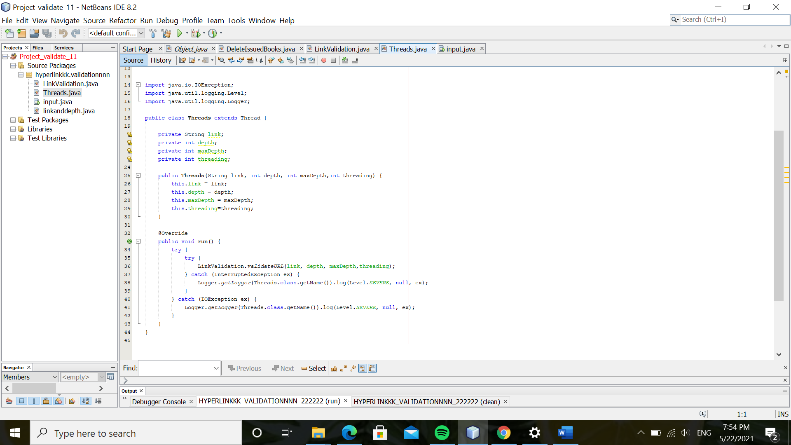

Linkanddepth: in this class we made the constructor and all setters and getter (accessors and mutators) for the input link , input max depth and threads

.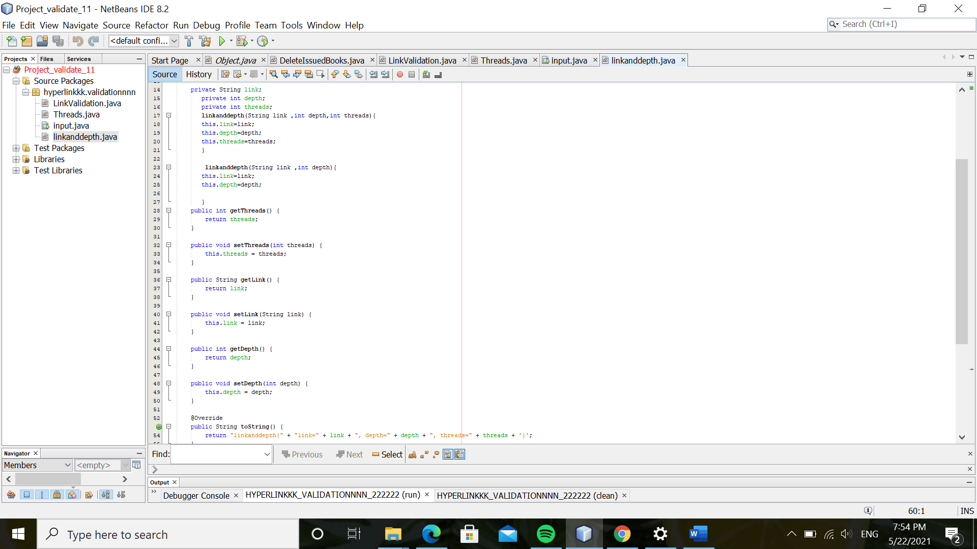

**Errors we faced:-**

We faced some errors but we fixed it in our program:

We had a problem in brackets.

At first threads we made didn’t run correctly.

The depth didn’t run correctly because of the problem in threads.

The minimum execution and number of threads of the university site :- <https://www.google.com/>

The minimum execution time is in number of threads 20 .

As shown in the inserted pictures :- if the number of thread decremented less than or incremented greater than 20 the execution time will be greater.

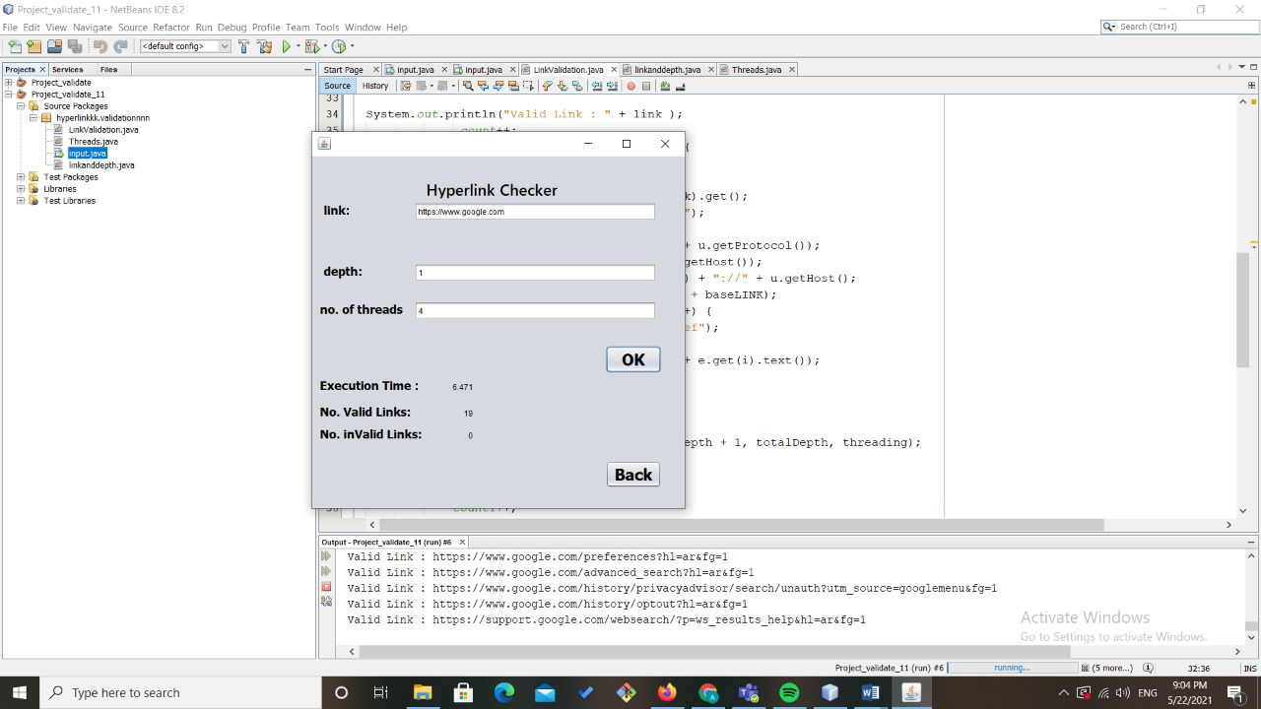

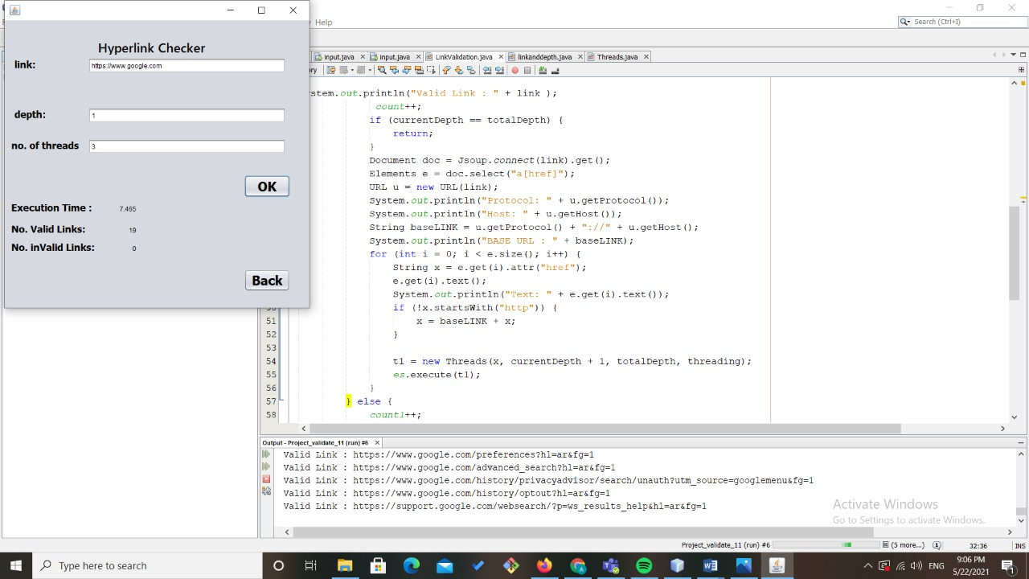

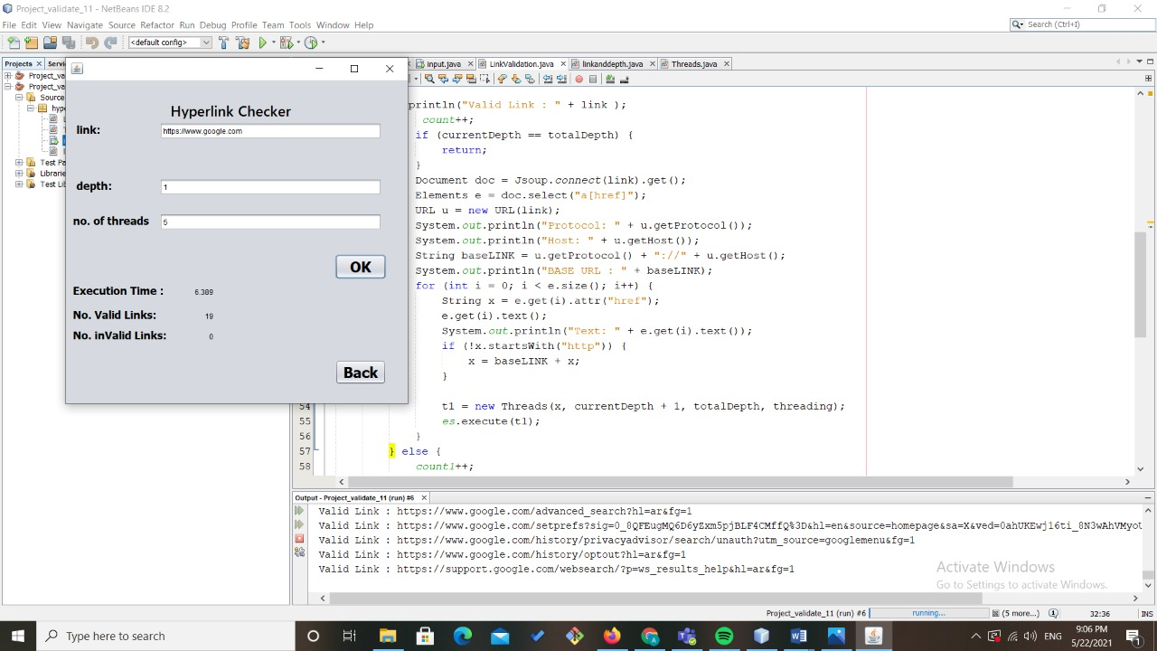

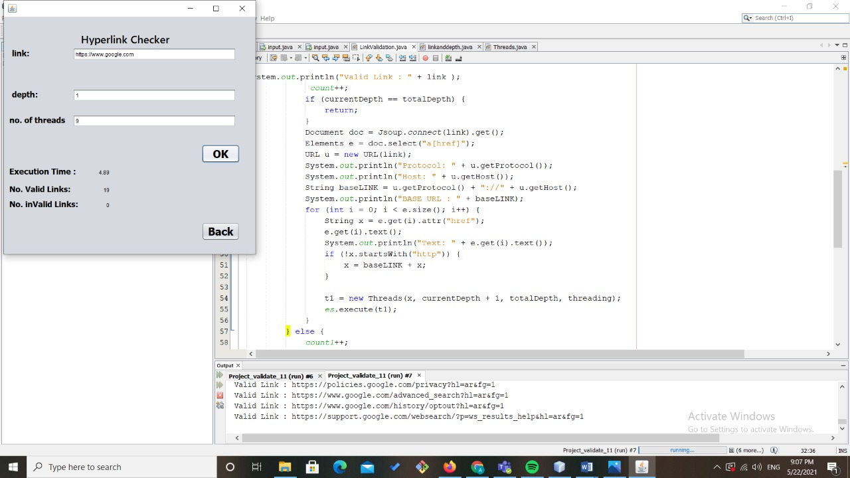

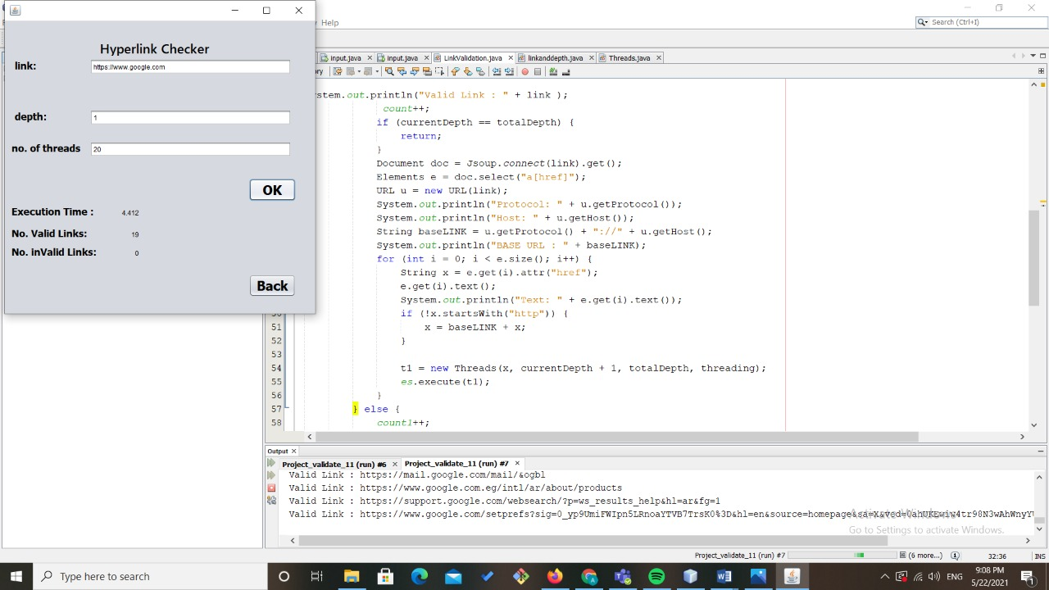

The minimum execution and number of threads of the university site :- [Alexandria University | جامعة الإسكندرية (alexu.edu.eg)](https://www.alexu.edu.eg/index.php/en/discover-au/4025-diamond-jubilee-celebrations-launch-in-alexandria-university)

The minimum execution time is in number of threads 75 because this site has more than 200 links valid and invalid inside it.

As shown in the inserted pictures :- if the number of thread decremented less than or incremented greater than 75 the execution time will be greater.

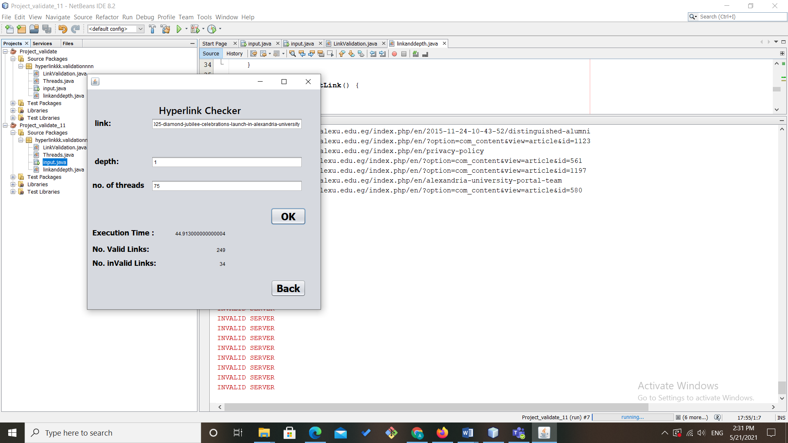

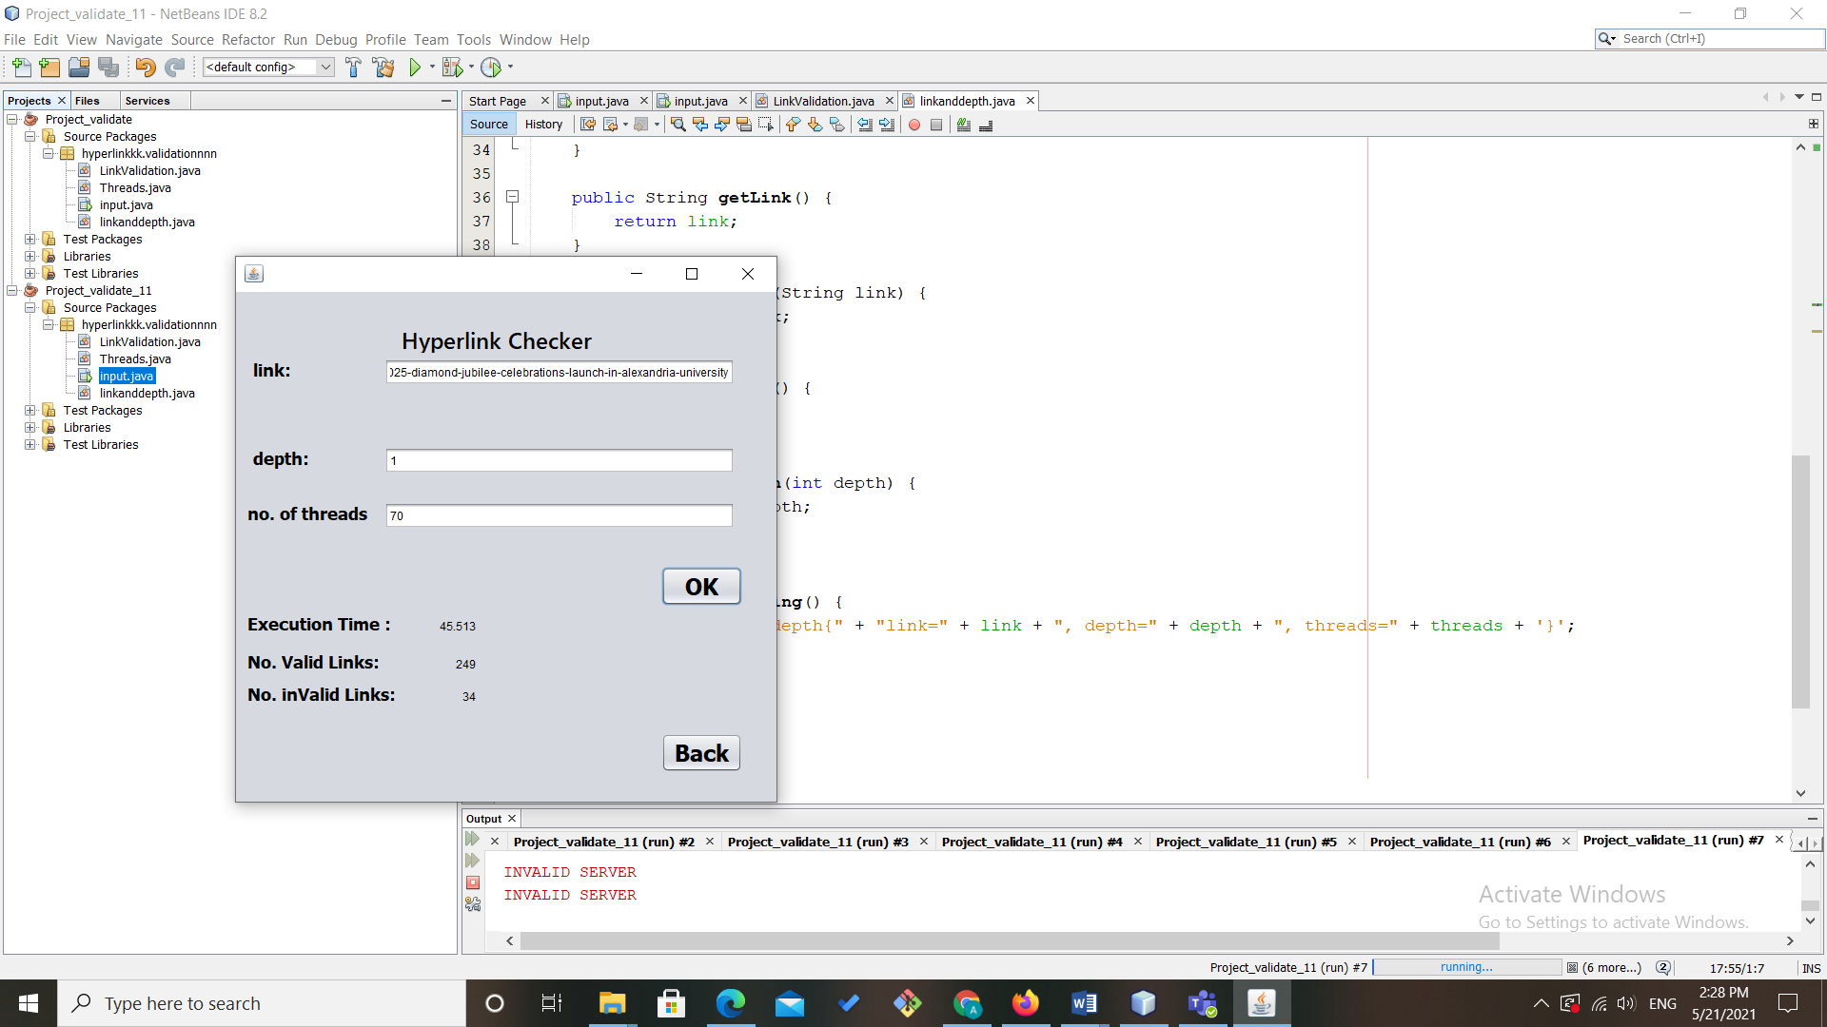

UML :

Use case diagram:

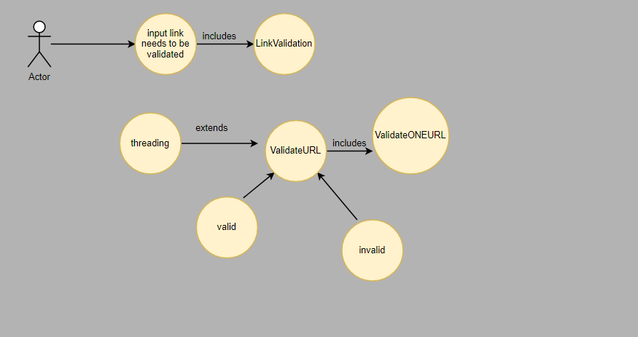

Activity diagram:

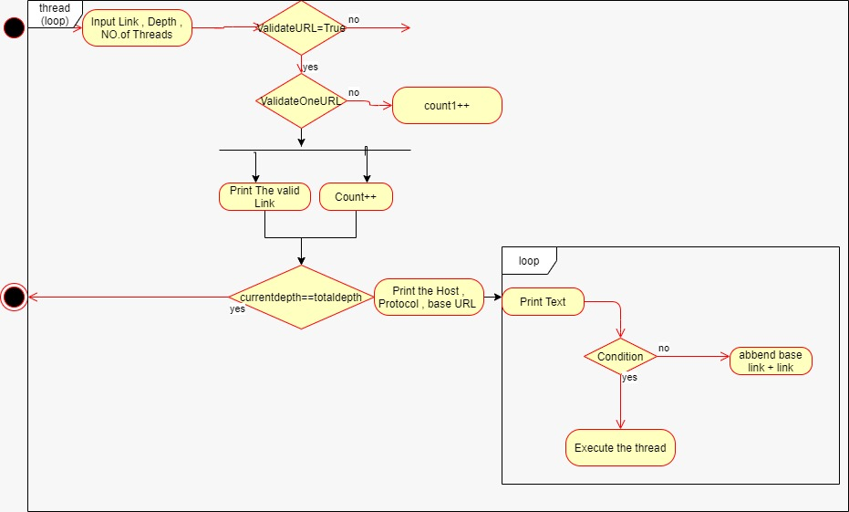

Class diagram:

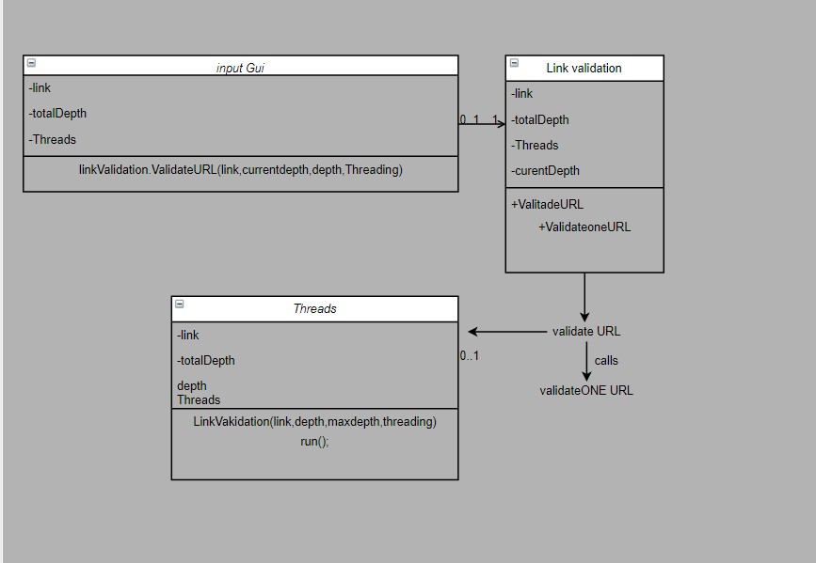

Sequential diagram:

